Name: | ___________________________________________________ |  | Date: ___________
 | Year 10 Pre-Stage 2 and 3  Take Home Component  (Review factorising and Expanding)  QUADRATIC FUNCTIONS – SOLVING EQUATIONS |  | = %
Total Time: | 55 minutes | Penalties (only deducted once in the whole assessment):   Rounding - Incorrect/inappropriate (-1)   Notation – incorrect/missing (-1)   Units - Incorrect/missing (-1)
Weighting: | _0___% of the year.
Equipment: | Scientific calculator and CAS calculator
Important Information:

Important Information:
Although the take-home component is not worth any marks, it is essential in preparation for the in-class component. Knowledge and skills gained will be extended in the in-class validation component. This in-class validation will be completed under test conditions on the day in which this take-home component is due. The take-home component may be used when completing the in-class component. Contact may be made to parent(s) if the take-home component is not available for submission (at the start of the lesson).

AIM: To review factorising quadratic functions and expanding and to understand how to solve the quadratic functions using different methods i.e. graphing and using CAS.

 | NOTES
A quadratic expression in x is an expression of the form ax² + bx+ c where x is the
variable, and a, b and c are constants with a ≠0:

ax² the x² term
+ bx the x term
+ c the constant term

For example:
x² + 5x + 6,
4x² - 9 and
9x² + 6x + 1 are quadratic expressions.

 | SOLVING EQUATIONS USING FACTORISING
In order to understand how to factorise the quadratic equation click the following link below:

http://www.purplemath.com/modules/factquad.htm

1. | Factorise x² + 5x + 4 = 0
Step 1
Write down all the possible numbers that can times together to give the last term of the equation (x² + 5x + 4 = 0) i.e. 4

Step 2

Out of all the possibilities above, pick a pair of two numbers that can add or take away to give you the middle term of the equation (x² + 5x + 4 = 0) i.e. +5

Step 3

Write your two numbers in the spaces below in the brackets with x.

(x + ⁪) (x + ⁪) = 0
Step 4

Write two answers for x:

2. | Factorise and solve the following using the above method:
a) | x² + 3x + 2 = 0
b) | x² + 3x – 10 = 0
c) | 2x² + 6x + 8 = 0  (Hint: Divide the whole equation by 2)  New equation will be  Solve it
d) | x² - x – 56 = 0
 | SOLVING THE EQUATIONS USING THE DIFFERENCE OF SQUARES
Click the link below to understand the difference of squares:

http://www.mathsteacher.com.au/year9/ch08_factors/05_difference/twosquares.htm

3. | Solve 4x² – 9 = 0 using the difference of squares
Step 1:

Factorise 4x² – 9
(Hint: you can rewrite the equation as (2x)² – (3)² as
(2x)² = 4x²
(3)² = 9

Step 2:
Write the two answers for x:

4. | Solve the following quadratic functions using the difference of squares.
a) | 4x² – 25 = 0
b) | 4x² – 1 = 0
c) | 9x² – 16 = 0
 | SOLVE THE EQUATIONS USING TI CAS CALCULATOR
5. | Follow the following prompts on CAS to solve the equations.
25x² – 10x + 1 = 0

Step 1
Turn the CAS calculator ON. Go to the calculator.



Step 2
On the Calculator screen either type ‘solve’ or press menu, then Algebra and then solve
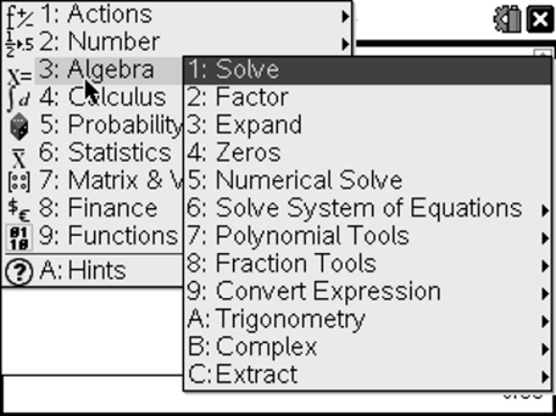
Step 3

Type the equation in your calculator as shown below:
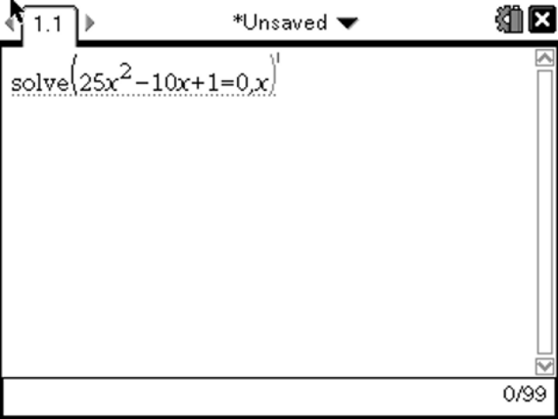

Press enter to get the desired result(s)

Answer for x = ________

6. | Solve the following quadratic functions using CAS calculator.
a) | P² – 49 = 0  Answers:
b) | 81 – y² = 0  Answers:
c) | (x – 3) ² – 4 = 0  Answers:
d) | 2x² - x = -2  Answers:
e) | 4x² +12x + 9 =0  Answers:
f) | 3x² - 2x – 5 = 0  Answers:

